High-Quality Child Care (Early Education/Education Environments) (Glossary Definition):

Refers to the characteristics of early learning and development programs that research has demonstrated are associated with positive child outcomes. These programs identify and support the needs of children from diverse cultures and who speak a language other than English, and ensures developmentally appropriate, culturally and linguistically responsive communication, activities, and parent engagement. These programs create a dynamic relationship between the family and the educator that works to define what the physical, social, emotional, and cognitive needs are for that child to ensure optimal learning environment for that child.

Overview of the “High-Quality Affordable Child Care: A Definition High-Quality Affordable Child Care: A Definition” Document:
The document titled “High-Quality Affordable Child Care: A Definition” creates a definition of high-quality child care (see section above) and describes the that supports that must in place for families, providers (educators), communities, and the education system create the infrastructure needed to support/produce high-quality settings. This document is broken into 5 sections that include:
- Quality Child Care and Early Education
- Affordability for Families
- Affordability to Providers
- Affordability to the Larger Community
- Looking forward

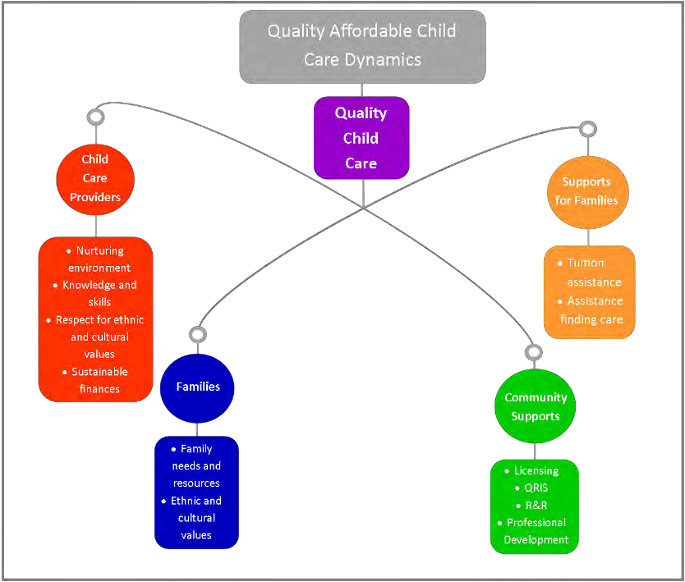

Each of these sections includes a rationale for there need, descriptions of current obstacles, and highlights of work that was happening in 2014 to move each of these sections closer to full implementation.
The final section of this document discusses some next steps for moving this work forward. It states that the Early Learning Council and the Oregon Education Investment Board, currently, the Chief Education Office, will adopt the Oregon Equity Lens as a key measure to address the achievement gap for children/youth from Oregon's communities of color. It also references that the Quality Rating and Improvement System (QRIS), currently, known as SPARK, will provide a foundation for all of these efforts and ensure that parents, providers, and policymakers have the data that they need guide investments.

Furthest From Opportunities:
Refers to communities that they Early Learning Council Equity Implementation Committee identified as African American, Asian and Pacific Islander, Children with disabilities, English language learners, Economic Disparities, Geographic Isolation, Immigrants and Refugees, Latino, and Tribal Communities.

Phillips, D. Mekos, D., Scarr, S., McCartney, K., & Abbott–Shim, M. (2000). Within and beyond the classroom door: Assessing quality in child care centers. Early Childhood Research Quarterly, 15, (4).

