|  |  |  |  |  |
| --- | --- | --- | --- | --- |
|  |  | |  | | --- | | Year in Review:  Early Learning Council Equity Implementation Committee 2016-2017 | |  | |
|  |  |  |
| Year in Review: 2016 – 2017 |  |  |

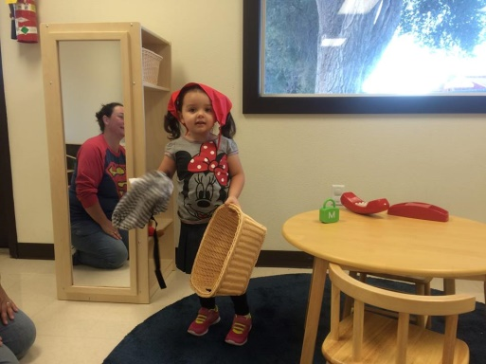

**Highlights**

**Equity Implementation Committee**

* Review of Charter
* Membership
* Implementation of a New ELC Committee Workflow
* Revamped Meeting Structure
* Review of EIC Principles

**Best Beginnings Committee**

* Family Support Questionnaire
* HFO Informational Presentation
* HFO-Accreditation Process / 5 year Strategic Plan/ Strategic Plan Questions
* MIECHV Informational Presentation
* Infant Toddler Assessment

**Childhood Care and Education Committee**

* Spark Rules
* Rules Governing Use of Vehicles in Child Care Setting
* Rules Governing Square Footage Requirements in Child Care Setting
* Rules Governing Staff Qualifications & Training

**Measuring Success Committee**

* Hubs Informational Presentation
* Key Bodies of Hub Work
* Hubs Metrics

**Spark Ad Hoc Committee**

* Spark Revisions
  + Standards and Tiers
  + Incentives
  + Community Engagement Strategies