Background Information on Observation Tools

Developed for Oregon Spark Ad Hoc Committee
September 2017

Importance of Adult-Child Interactions and Need for Observation Tools

The proposed Spark Standards have an increased focus on adult-child interactions. Focusing on adult-child interactions makes the revised system more responsive and research based. First, from a family perspective, the relationship that educators have with their children and how they interact is a significant factor in choosing quality child care. Building systems to measure, improve, and provide feedback and support on adult-child interactions helps increase quality that is valued by families. Second, research indicates that adult-child interactions impact child outcomes. QRISs are built to improve and measure quality so that children are learning and prepared for school and life.

Adult-child interactions are best measured by observation, and the proposed standards include standards that can be measured trained reliable observers using research based tools. This document was prepared to address some of the questions about observation tools as we look at how we measure adult-child interactions in Oregon’s Spark.

Classroom Assessment Scoring System (CLASS) for Oregon Spark

1. What is CLASS? What exactly does it measure?

The Classroom Assessment Scoring System (CLASS) is an observational tool designed by researchers at the University of Virginia and developed by Teachstone. It measures the quality of adult-child interactions and thus learning environments in child care programs. (See the attached chart from Teachstone.)

2. What research was used to develop the CLASS observation tool?

CLASS domains and dimensions are based on developmental theory and research suggesting that interactions between children and adults are the primary way of supporting children's development and learning, and that effective, engaging interactions and environments form the foundation for all learning in early childhood classrooms. Teachstone used research-based, valid indicators and behavior markers of interactions and environment in their development of the tool.

The Administration for Children and Families selected CLASS, “an instrument that has been validated by over 10 years of research in educational settings,” as a tool for measuring quality in its Head Start programs. Along with the Environmental Rating Scale (ERS) tools, the Office of Head Start (OHS) chose CLASS because it derives from “developmental theory and research suggesting that interactions between children and adults are the primary way of supporting children's development and learning, and that effective, engaging interactions and environments form the foundation for all learning in early childhood classrooms.”

3. How is CLASS imbedded in early childhood systems?

Approximately half (45%) of states use the CLASS tool for center-based program quality rating, improvement, or both, and 17% use CLASS for home-based programs. Several states use CLASS to establish content areas and goals for professional development and technical assistance. (See question 4.) In addition, CLASS Pre-K is a key component of program quality rating in Head Start, where it is used for reviews, Designation Renewal, and professional development.

4. How can CLASS support Continuous Quality Improvement (CQI)?

Several states and the OHS use CLASS to support CQI. For example, states such as Georgia and Maryland report that CLASS has improved program quality not only in relationship to adult-child interactions but between professionals in individual programs and throughout the QRIS system as a whole, providing research-based best practices and a vocabulary to drive self-assessments and quality improvement plans. The staff development tools used by the Office of Head Start (OHS)-funded National Center on Early Childhood Development (formerly the National Center on Quality Teaching and Learning) for improving preschool classroom teaching practices align with CLASS dimensions, and regional OHS Early Childhood Education Specialists that work directly on-site with local programs are certified as CLASS trainers, incorporating the tool into all of their work on classroom interactions.

5. How can CLASS be used with multiple age groups?

There are six CLASS tools, measuring infant, toddler, and pre-K environments as well as K-3, upper elementary, and secondary classrooms. (See attached Teachstone chart.) Teachstone recommends that observers in multi-age settings “alternate between two age levels in order to capture the experiences of most children and produce independent scores between the age levels.” with an emphasis on the majority group.

6. What concerns have been raised about using CLASS as a tool to rate and promote program quality?

A recent Brookings report cautions that both CLASS and the ERS tools should be viewed with awareness of their priorities and limitations. While there is widespread agreement that interactions are crucial, the field needs more empirical evidence in support of these tools:

Each of them represents a set of developers’ ideas about what was likely to be important for young children’s development. Each has a great deal of face validity and thus each has convinced policy makers to incorporate them into policy in consequential ways. But while face validity and ideology can provide the starting point of an investigation, they must be supplemented with rigorous research actually validating their use before they are adopted into policy.

A similar knowledge gap concerns the use of such tools in high-stakes accountability systems. When the Office of Head Start integrated CLASS as a criteria for determining which programs would need to recompete for their Head Start grant, it became high-stakes. In its report on the Head Start Designation Renewal System, the Office of Planning, Research, and Evaluation found concerns “about the precision of the CLASS as a measure of grantee-level quality and about its ability to identify lower-performing programs for competition.” These concerns reflect that the Office of Head Start is required by policy to take the lowest 10% of programs in each respective CLASS domain (in any domain where the threshold score has not been met). This means that the difference in scores to arrive at this 10% is not necessarily statistically significant or an adequate indicator of which program should recompete. It is also related in part to discrepancies between CLASS scores measured by grantee staff and those measured by OSH Designation Renewal staff. In its response to that report, Teachstone (which owns CLASS) pointed out that “[h]igh-stakes accountability systems are relatively new in early childhood education; as a result, the field still has much to learn about how to most effectively use observational measures within these systems.”

Despite these concerns, CLASS continues to be used throughout the country in both state and federal systems. This is due both to the prominence of the tool (see question 7) and to a preponderance of research data about the critical role of teacher-student interactions in early childhood programs. So, while a more recent Brookings report stressed the need for more long-term studies, it did so while stressing the importance of “improving the quality of teacher-child interactions” as an immediate goal. As the authors state,

While we await these long-term results, we do not have to sit idly by, hands tied. A half century of early childhood research tells us where to focus our attention—improvement of the quality of early education and care.

7. Are we restricted to using CLASS if other tools that are more culturally responsive and/or have greater empirical evidence in the measurement of Adult/Child interactions become available? What other options exist for early childhood systems wanting to measure interactions to rate and promote program quality? Are we restricted to using CLASS if other tools that are more culturally responsive and/or have greater empirical evidence in the measurement of Adult/Child interactions become available?

We are identifying the measurement of Adult/Child interactions at certain levels in our Spark system; framing it in this way means we are able to consider more appropriate tools when they come available. It is important to support the value that families and research have placed on Adult/Child interaction with the most responsive tools available.

Many resources exist to document observations of interactions in early childhood settings: qualitative tools like anecdotal or running records; program-derived tools such as checklists; curriculum-specific instruments from early childhood curriculum companies; and targeted instruments that focus on reducing challenging behavior or promoting math or literacy development. With few exceptions, the resources and tools created to measure interactions solely have been designated for research use alone. These also have issues when taken to a state system scale.

Thus, besides CLASS, the only instrument routinely used to compile quantitative measurements to rate and promote quality interactions are the Environmental Ratings Scale (or ERS) tools. The ERS tools are limited, however, with interactions as only one of six subscales, ERS ratings do not provide the granularity of the CLASS tool. In addition, the concerns raised in question 6 about CLASS have also been raised about the ERS tools as well. For that reason, many states use both the ERS tools for general program quality and the CLASS tools to measure interactions in a more focused manner.

8. What would be appropriate messaging if Oregon Spark incorporates CLASS into the QRIS?

CLASS provides Oregon Spark with a research-based observation tool that many states use both to measure quality and to support continuous quality improvement through their QRIS system . It is also the system that the Office of Head Start uses to measure program quality and address continuous improvement in their classrooms nationwide.. While research grows regarding some aspects of its use, CLASS is built upon a strong research framework that identifies valid indicators of program quality. As a result, despite some reliability concerns, CLASS is currently the best tool available to document, measure, and explore the ways that classrooms and thus programs build strong environments through the healthy, supportive interactions— a foundational quality principle of Oregon Spark.

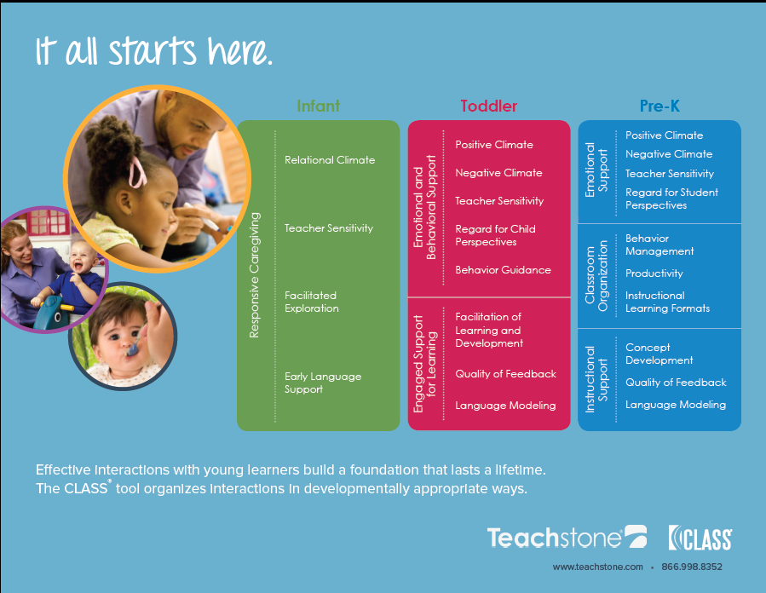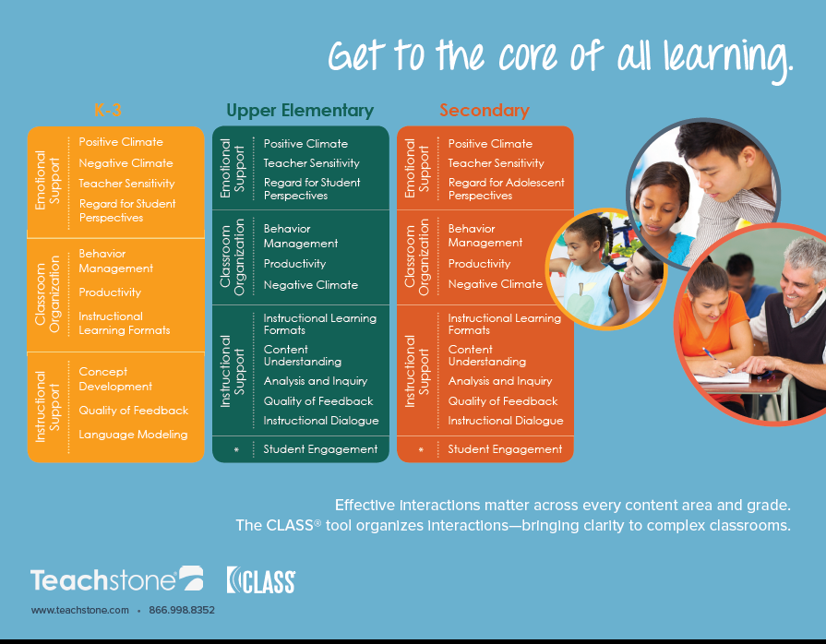

School-Age Program Quality Assessment for Oregon Spark

1. What is the School-Age Program Quality Assessment (PQA)?

The School Age PQA is an observational tool designed by staff at the David P. Weikart Center for Youth Program Quality in Ypsilanti, Michigan. It is a validated, evidence-based instrument designed to evaluate the quality of youth programs and identify staff training needs. The School-Age version is designed for students in grades K-6. The PQA can be used in out-of-school programs such YMCA or school-based classroom settings.

2. What does the School-Age PQA measure?

The School-Age PQA has four Domains: Safe Environment, Supportive Environment, Interaction, and Engagement. A total of 20 Scales with 70 items are contained under these four Domains. Each item is scored 1 (not present), 3 (occurs at least one time), or 5 (occurs several times).

3. Why is the School-Age PQA instrument being recommended for Spark?

PQA is a validated instrument and is evidence based. The PQA has numerous items that measure the Spark Learning and Development (LD) and Positive Relationship (PR) Domains at the 4-Star level. Other instruments such as the School Age Care Environment Rating Scale (SACERS) and the Family Child Care Environment Rating Scale – Revised Edition (FCCERS-R) each only contain six items that measure either Learning and Development or Positive Relationships; the PQA has 41 items that measure these 2 domains. The CLASS K-3 and Upper Elementary tools are designed for school classrooms and are not intended for out-of-school programs. The PQA can also be used to support continuous quality improvement by identifying program and staff training needs.

4. What PQA Scales align with Spark?

Emotional Safety – 2 items (PR)
Warm Welcome – 3 items (PR)
Session Flow – 5 items (LD)
Active Engagement – 3 items (LD)
Skill Building – 5 items(LD)
Encouragement – 2 items (PR)
Managing Feelings – 4 items (PR)
Belonging – 4 items (PR)
Interactions with Adults – 4 items (PR)
School-Age Planning – 3 items (LD)
School-Age Choice – 2 items (LD)
Reflection – 2 items (LD)
Responsibility – 2 items (LD)

http://qriscompendium.org/glossary/data-options-glossary-terms.
https://eclkc.ohs.acf.hhs.gov/hslc/hs/sr/class/use-of-class.pdf.
https://eclkc.ohs.acf.hhs.gov/hslc/hs/sr/class/use-of-class.pdf.
https://eclkc.ohs.acf.hhs.gov/hslc/hs/sr/class.
http://qriscompendium.org/top-ten/question-3.
https://eclkc.ohs.acf.hhs.gov/hslc/hs/sr/class.
http://info.teachstone.com/blog/behind-the-curtain-a-look-at-georgia-class-implementation.
http://info.teachstone.com/blog/using-class-in-statewide-qris-without-being-used-as-a-gotcha-measure.
https://eclkc.ohs.acf.hhs.gov/hslc/hs/sr/class/use-of-class.pdf.
http://info.teachstone.com/blog/observing-mixed-age-groups-at-family-child-care-providers.
https://www.brookings.edu/research/we-need-more-evidence-in-order-to-create-effective-pre-k-programs/. NB: This report was written by Dale Farran in February 2016; the author’s research team is developing its own observation tool.
https://www.brookings.edu/articles/early-childhood-development-the-promise-the-problem-and-the-path-forward/.
https://www.acf.hhs.gov/opre/resource/early-implementation-of-the-head-start-designation-renewal-system-volume-i-ii.
https://www.brookings.edu/blog/education-plus-development/2017/03/27/realizing-the-promise-of-high-quality-early- childhood-education/. This report, dated March 2017, was written by Andres S. Bustamante, Deborah Lowe Vandell, Kathy Hirsh-Pasek, and Roberta Michnick Golinkoff.
https://qrisguide.acf.hhs.gov/files/Program_Assessment.pdf.

