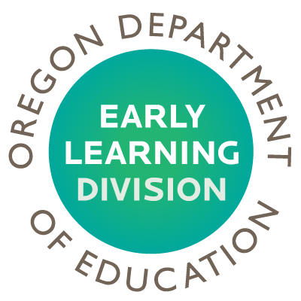
The Oregon Early Learning Division
Equity Lens: Eight Questions

Proposed Staff Training Requirements for Licensed Child Care Providers

- Who are the racial/ethnic and underserved groups affected? What is the potential impact of the resource allocation to these groups?
Based on information received from field staff and public comment, providers of low income could be impacted. Increased training opportunities and accessibility could require additional resources particularly for individuals whose home language is not English.

- Does the decision being made ignore or worsen existing disparities or produce other unintended consequences? What is the impact on eliminating the opportunity gap?
The potential to worsen existing disparities does exist, such as further decreasing an affected provider’s income source by increasing their expenditures in additional training fees, travel time and time loss from work. However, the benefit to the professionalism and increased quality of caregiver/child interaction must be considered.

- How does the investment or resource allocation advance the 40/40/20 goal?
Increasing minimum professional development requirements has the potential to increase caregiver/child interaction which could advance the 40/40/20 goal.

- What are the barriers to more equitable outcomes (e.g. mandated, political, emotional, financial, programmatic or managerial)?
Current training requirements are below national standards. Benefits of increased professional development for licensed child care providers must be considered against potential barriers.

- How have you intentionally involved stakeholders who are also members of the community affected by the resource allocation? How do you validate your assessment in (1), (2) and (3)?
Field staff that work directly with providers that may be impacted by the proposed requirement were consulted. The proposed requirement was discussed at a recent Child Care and Education Committee public meeting. Further engagement will be conducted with provider groups and parents, specifically targeting those groups that may be impacted. Field staff that directly work with providers that may be impacted will conduct engagement with those populations.

- How will you modify or enhance your strategies to ensure each learner and communities’ individual and cultural needs are met?
Input received from the engagement will assist in determining which variation of the proposed requirement would be the most appropriate to accomplish the goal of benefitting children and minimizing the impact to affected providers.

- How are you collecting data on race, ethnicity and native language?
Direct engagement with populations that may be impacted. Data is also being collected through the child care information system, resource and referral information and training information.

- What is your commitment to professional learning for equity? What resources are you allocating for training in cultural responsive instruction?
Ongoing as part of the Early Learning Division’s commitment to equity.

