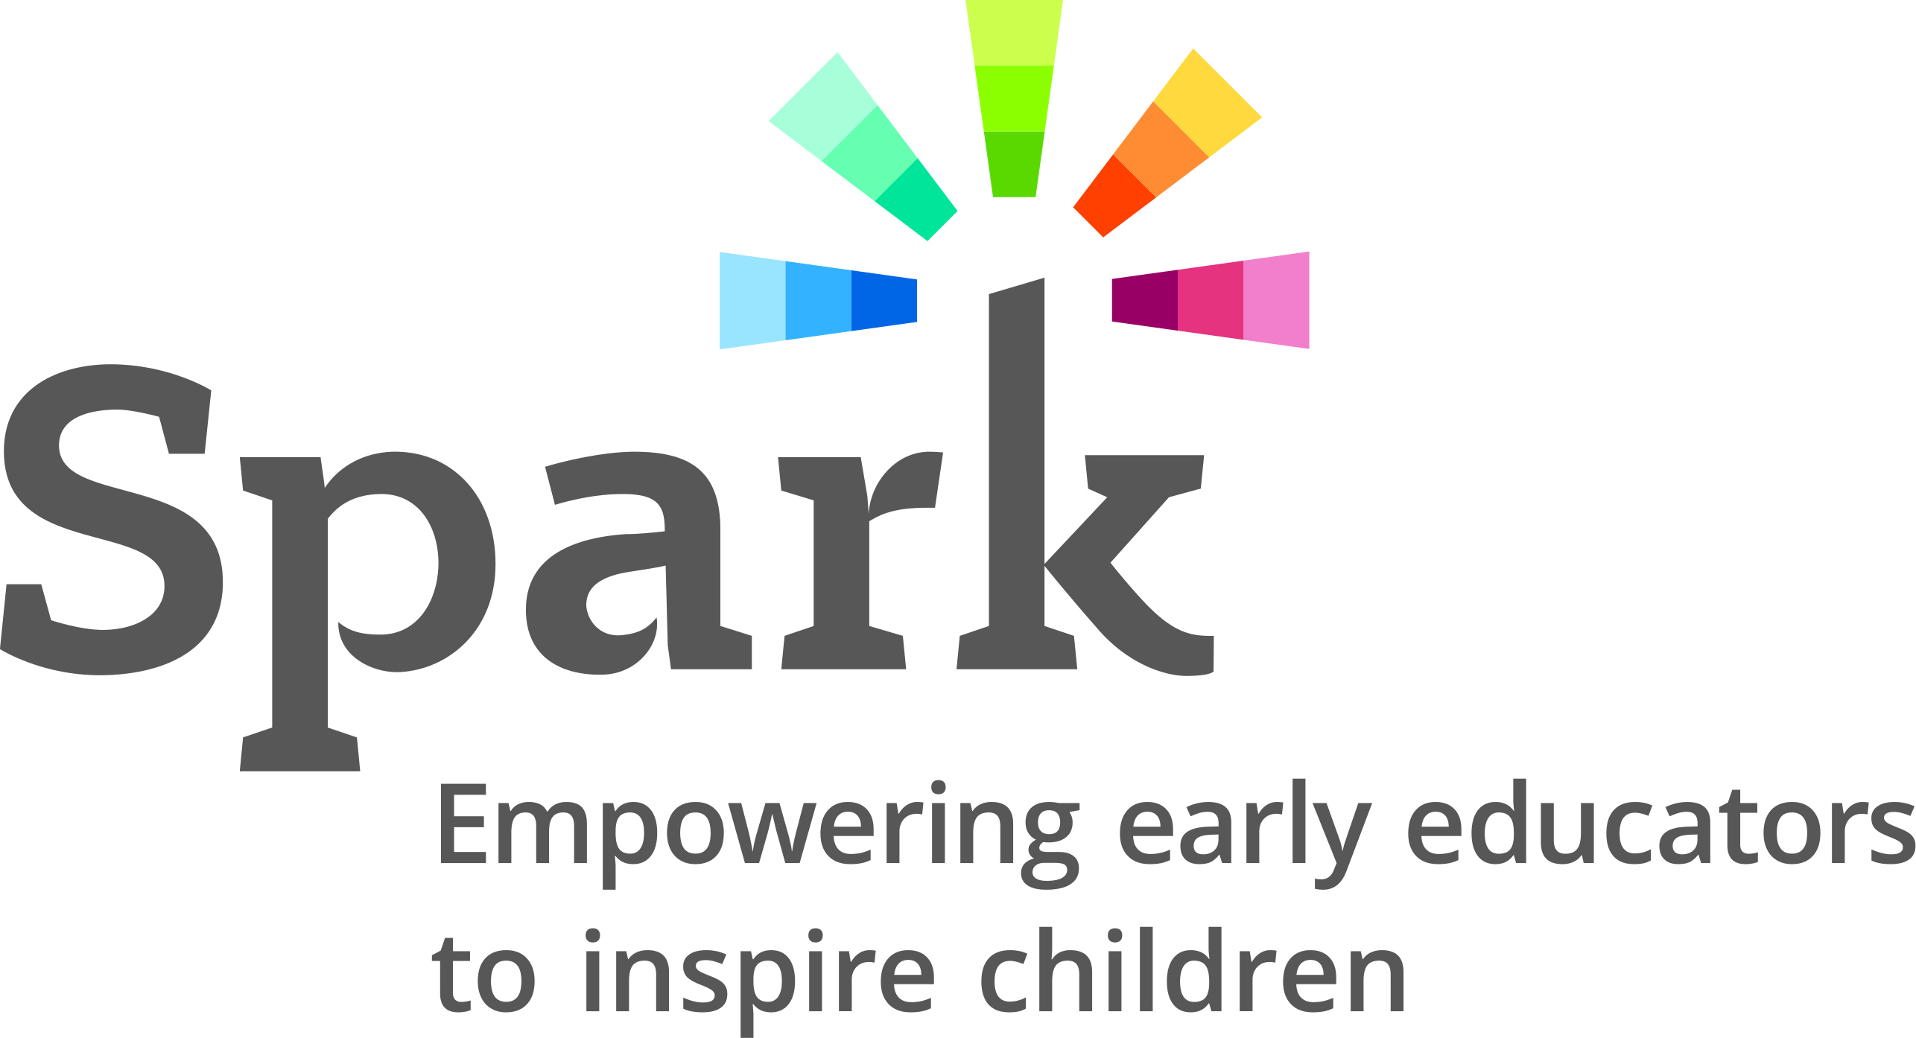
Spark Revision Ad Hoc Committee

Recommendations for

Spark Tiers and Standards Draft

(Reflecting April Committee discussions)
- Connect the category of standards across tiers (or star ratings), all categories should be included in every tier.
- Create a plan to connect back to the communities who offered initial feedback (before Spark Tiers and Standards are finalized) to assure that the improvements to the Spark Tiers and Standards addressed their presented concerns and meets their needs.
- Update language to be more reflective of School Age and Family Child Care environments (use multiple spaces vs. multiple rooms); add in youth voice and youth choice.
- Add more incorporation of home and home culture as descriptions and evidence are built out.
- Further discussion/work needs to be done around incorporating School Age programs.

Areas where further information is needed

before recommendations can be made
- Assure the system focuses on continuous quality improvement and is viewed less from the rating perspective. Conversation occurred around framing the system and whether utilizing star ratings vs. tiers best meets this objective. Committee agreed it was important to have benchmarks, but to keep the focus on growing and improving. Committee questioned whether the tiers were differentiated enough and if having different standards per category makes it harder to determine this. Some of the categories (especially 4) seemed vague and need further build out. – On agenda for 5/2017 Committee Meeting
- More discussion is needed around Education Qualification (specifically noted was the 3 star rating requiring a 7.5 vs. a 7) and the form for looking at qualifications. The form was viewed as a good idea, but members were unsure how to use the form and need more direction on use of the form. – On agenda for 5/2017 Committee Meeting
- Discussions arose regarding utilizing CLASS as the observational tool; questions around if/how it addresses bias (specific reference of a Brookings study), notation that use of CLASS in school age environments was not included in the validation study, and a note that there is strong reliability/validity in utilizing CLASS due to the rigor of certifying observers. - On agenda for 6/2017 Committee Meeting
- The committee would like to look at the standards across tiers and look at each component to see how it builds to the next tier. On agenda for 6/2017 Committee Meeting

Additional Areas

Requiring further action
- The committee noted a desire to see social justice better reflected in standards and system.
- Committee members noted the removal of staff wellness as an indicator and expressed that they felt staff wellness is an indicator of a quality program. It was further noted that parents look at the satisfaction of staff working at a program.
- It was noted that the following areas were not included in the Tiers and Standards:
    - Involvement in a professional organization (or community) as evidence/indicator
  - Staffing that reflects the language of population of children and families
  - Children and families served by the program are reflective of the needs of the larger community
  - Utilizing self-reflection or coaching as a tool
  - ASQ as the standardized screening tool (noted that the Hubs and community organizations are encouraging the screening and referral of children needing services and this is the tool they are utilizing)

