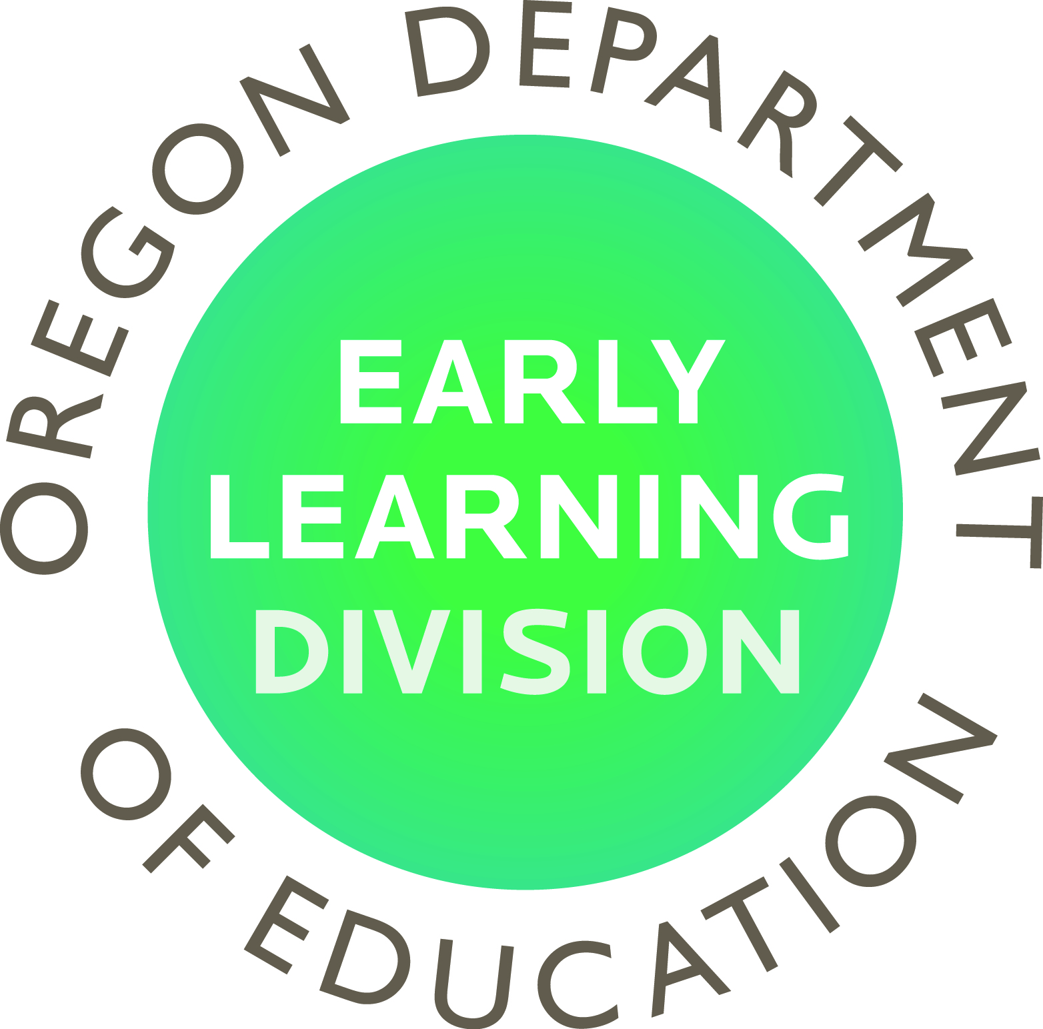

April 2017 Infant Toddler Statewide Self- Assessment Talking Points

What is the Infant Toddler Self-Assessment tool? The tool , put out by Zero to Three®, provides guidance for a statewide assessment of infant-toddler early learning needs, and the presence or absence of state policies and systems to create a comprehensive quality statewide system of support for infants and toddlers and their families. The design of the tool prompts you to compile a set of targeted data points and related narrative, and collect feedback from early learning stakeholders and families of young children.
How did Oregon become interested?
Oregon’s Early Learning Division was introduced to the Zero to Three® Infant Toddler Self-Assessment Tool through work with Zero to Three® Specialist Jamie Colvard a couple years ago. More recently, Teaching Research Institute at WOU and the Oregon’s Early Learning Division’s Office of Child Care received a TA grant through the BUILD Initiative and the National Center of Early Childhood Quality Assurance (NCEQA) to establish an Infant-Toddler Peer learning Group, comprised of a variety of infant-toddler stakeholders in the field of childcare, early childhood policy, health policy and home visiting. Through the work of the peer learning group, the Early Learn Division was further inspired to launch the process of completing this tool together with the Oregon Health Authority, support from Children’s First of Oregon and other early learning stakeholders.
Our Process
Early Learning Division staff and partners are in the first of a multi-phase process to complete the tool. In this first phase the focus is to engaging stakeholders and collect data, including use of stakeholder and family surveys. By the end of June, Early Learning Division plans to have vetted the data analysis and to share the results with stakeholders.
Goal
Out of the analysis and in collaboration with our partners, a set of recommendations will be developed for policy-makers, along with strategic plan to guide statewide infant-toddler work. This work is to completed by August of 2017.

