3, 6, 12 Month Training Log
Healthy Families Learning Center Training Modules

TT - Code | HFA Standard | Description | HFA On-Line E Learning Center Courses | Date Completed | Supervisor  Initials
 |  | WITHIN 3 MONTHS OF HIRE
 | 11-2.A | Infant Care (3 of 4 Required) | Keeping Babies Healthy & Safe
15 | 1 | Infant Sleeping Patterns | Course 1
16 | 2 | Feeding/Breastfeeding Promotion | Course 1
17 | 3 | Physical Care of Baby | Course 1
18 | 4 | Crying and Comforting/Consoling a Baby | Course 1
 | 11-2.B | Child Health & Safety (5 of 8 Required) | Keeping Babies Healthy & Safe
346650 | 1 | Assessing & Promoting Home Safety | Course 1
346651 | 2 | Shaken Baby Syndrome | Course 1
346652 | 3 | SIDS - Sudden Infant Death Syndrome | Course 1
346653 | 4 | Seeking Medical Care | Course 1
349857 | 5 | Promoting Well Child Visits & Immunizations | Course 1
349858 | 6 | Seeking Appropriate Child Care | Course 1
349925 | 7 | Car Seat Safety | Course 1
349926 | 8 | Failure to Thrive | Course 1
 | 11-2.C | Maternal & Family Health (3 of 4 Required) | Prep Moms for Birth & Beyond, Recog. Perinatal Depression
349927 | 1 | Family Planning | Course 2 and Course 12
350529 | 2 | Nutrition | Course 2 and Course 12
350532 | 3 | Pre/Post-Natal Health Care | Course 2 and Course 12
350575 | 4 | Pre-Post-Natal Depression | Course 2 and Course 12
 |  | WITHIN 6 MONTHS OF HIRE
 | 11-3.A | Infant & Child Development (3 of 4 Required) | Fostering Infant & Child Development
350578 | 1 | Language/Literary Development | Course 3
350587 | 2 | Physical & Emotional Development | Course 3
350589 | 3 | Identifying Emotional Delays | Course 3
350590 | 4 | Brain Development | Course 3
 | 11-3.B | Supporting the Parent-Child Relationship (4 of 6 Required) | Coaching on Positive Parenting Strategies
350596 | 1 | Methods for Supporting Attachment | Course 4
350597 | 2 | Positive Parenting Strategies | Course 4
350598 | 3 | Discipline Techniques | Course 4
350628 | 4 | Supporting Parent-Child Interactions | Course 4
350629 | 5 | Observing & Assessing Parent-Child Interactions | Course 4
350631 | 6 | Strategies for Working with Difficult Parent-Child Relationships | Course 4
 | 11-3.C | Staff-Related Issues (4 of 6 Required) | Optimizing Your Effectiveness
351698 | 1 | Stress & Time Management | Course 9
351699 | 2 | Burnout Prevention | Course 9
351700 | 3 | Personal Safety of Staff | Course 9
351701 | 4 | Ethics | Course 9
351702 | 5 | Crisis Intervention | Course 9
351703 | 6 | Emergency Protocols | Course 9
 | 11-3.D | Mental Health (3 of 5 Required) | Promoting Mental Health
350968 | 1 | Promotion of Positive Mental Health | Course 11
350969 | 2 | Behavioral Signs of MH Issues | Course 11
350970 | 3 | Depression | Course 11
350971 | 4 | Strategies for Working with Families with MH Issues | Course 11
 |  | WITHIN 12 MONTHS OF HIRE
 | 11-4.A | Child Abuse & Neglect (2 of 2 Required) | Preventing Child Abuse
19 | 1 | Etiology of Child Abuse and Neglect | Course 5
350967 | 2 | Working with Survivors of Abuse | Course 5
 | 11-4.B | Family Violence (4 of 7 Required) | Addressing Domestic Violence
350706 | 1 | Indicators and dynamics of Family Violence | Course 6
350707 | 2 | Strategies for Working with Families with Domestic Violence Issues | Course 6
350714 | 3 | Intervention Protocols | Course 6
350718 | 4 | Intervention Strategies | Course 6
350724 | 5 | Referral Resources for Domestic Violence | Course 6
350859 | 6 | Effects on Children | Course 6
 | 11-4.C | Substance Abuse (5 of 8 Required) | Recog. Substance Abuse, Striving for Smoke Free Environment
350905 | 1 | Etiology of Substance Abuse | Course 7 and Course 8
350921 | 2 | Culture of Drug Abuse | Course 7 and Course 8
350934 | 3 | Strategies for Working with Families with Substance Abuse Issues | Course 7 and Course 8
350956 | 4 | Smoking Cessation | Course 7 and Course 8
350962 | 5 | Alcohol Use/Abuse | Course 7 and Course 8
350964 | 6 | Fetal Alcohol Syndrome | Course 7 and Course 8
350965 | 7 | Street Drugs | Course 7 and Course 8
350966 | 8 | Referral Resources for Substance Abuse | Course 7 and Course 8
 | 11-4.D | Family Issues (4 of 6 Required) | Responding to Relationships
350997 | 1 | Life Skills Management | Course 10
350998 | 2 | Engaging Families | Course 10
350999 | 3 | Multi-Generational Families | Course 10
351000 | 4 | Teen Parents | Course 10
351001 | 5 | Family Relationships | Course 10
351002 | 6 | HIV and AIDS | Course 10
 | 11-4.E | Role of Culture in Parenting (2 of 3 Required)
350591 | 1 | Working w/Diverse Cultures/Populations | Covered in all HFA Courses
350592 | 2 | Culture of Poverty | Covered in all HFA Courses
350593 | 3 | Values Clarification | Covered in all HFA Courses
Additional Information:

There is a handout indicating what is covered in each course:
You have the option to print the "Objectives" page. (See details for printing below)

There is a handout to follow along with the course for taking notes and to refer back to.
You have the option to print the “job aides" if that will be helpful. It is a lot of paper, so you may want to consider one hard copy per program.

What do I do if I can’t finish one of the course modules and have to return to it later?
When you log back in to complete the course, you will find that it does not automatically hold your place. Therefore, make sure you remember where you left off previously and keep clicking on “Next” in rapid succession (you don’t have to let each screen load unless you want to view something again) until you get to the place where you left off. If you finished the module but did not have time to take the test, log-in and click on “Take a Test”.

PRINTING from healthyfamiliesTLC.com:
- Login
- Click on "View Available Courses"
- Select a course - "Course 01: ______" (you will repeat this step for each course)
- Select "Job Aids" to open a menu of PDF documents you can print
- Repeat for "Objectives”
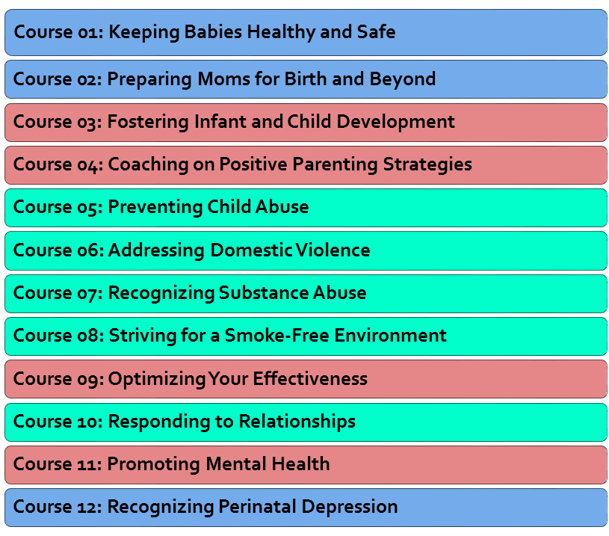
Blue = 3 month requirements Red = 6 month requirements Green = 12 month requirements

